JAVA ASSIGNMENT 8

Name - Palak Kumari
Roll No - 25SCS1003001665
Course - B.Tech CSE
Subject - Java Programming

Questions1. Explain Polymorphism in Java.
Ans : Polymorphism is an important concept of Object-Oriented Programming (OOP) in which a single method, object, or operation can behave in different ways depending on the situation.
The word Polymorphism means “many forms.” In Java, polymorphism allows the same method name to perform different tasks.
Importance of Polymorphism:
- It makes programs more flexible and easier to maintain.
- It allows the same method name to be used for different purposes.
- It supports code reusability and makes programs easier to understand.
Example:
class Student {
void study() {
System.out.println("Student is studying");
}
}
Here, the study() method represents an action that can have different implementations in different classes.

Question 2. Explain the Types of Polymorphism
Ans: There are mainly two types of polymorphism in Java:
a) Compile-Time Polymorphism (Static Polymorphism)
Compile-time polymorphism is achieved through Method Overloading. In this, more than one method has the same name but different parameters. The method to be executed is decided by the compiler at compile time.
Example:
class Calculator {
int add(int a, int b) {
return a + b;
}

int add(int a, int b, int c) {
return a + b + c;
}
}
Here, both methods have the same name add() but different numbers of parameters. Therefore, this is compile-time polymorphism.
b) Run-Time Polymorphism (Dynamic Polymorphism)
Run-time polymorphism is achieved through Method Overriding. In this, a derived class provides its own implementation of a method that is already present in the base class. The method to be executed is decided at run time.
Example:
class Animal {
void sound() {
System.out.println("Animal makes a sound");
}
}

class Dog extends Animal {
void sound() {
System.out.println("Dog barks");
}
}
Here, the Dog class overrides the sound() method of the Animal class. Therefore, the method that runs depends on the object at run time.

Question 3. Explain Method Overloading
Ans: Method Overloading is a feature of Java in which two or more methods have the same name but different parameters in the same class. It is an example of compile-time polymorphism.
Rules of Method Overloading
- The methods must have the same method name.
- The methods must have different parameters.
- Parameters can differ in their number, type, or order.
- Changing only the return type is not enough to overload a method.
Different Ways to Overload a Method
A method can be overloaded in the following ways:
1. By changing the number of parameters:
void display(int a)
void display(int a, int b)
2. By changing the data type of parameters:
void display(int a)
void display(double a)
3. By changing the order of parameters:
void display(int a, double b)
void display(double a, int b)
Why changing only the return type is not Method Overloading
Changing only the return type of a method does not make it overloaded because Java identifies a method mainly using its method name and parameter list. Therefore, two methods cannot have the same name and same parameters with only different return types.
For example:
int add(int a, int b)
double add(int a, int b)
This is not valid method overloading because the parameter list is the same.
Difference between Method Overloading and Method Overriding
Method Overloading | Method Overriding
Same method name with different parameters. | Same method name with the same parameters.
Usually occurs in the same class. | Occurs between base class and derived class.
It is compile-time polymorphism. | It is run-time polymorphism.
It does not require inheritance. | It requires inheritance.
The method is selected at compile time. | The method is selected at run time.

- Calculator Addition
Program :
class Calculator {

int add(int a, int b) {
return a + b;
}

int add(int a, int b, int c) {
return a + b + c;
}

double add(double a, double b) {
return a + b;
}

public static void main(String[] args) {

Calculator obj = new Calculator();

System.out.println("Addition of two integers: " + obj.add(10, 20));

System.out.println("Addition of three integers: " + obj.add(10, 20, 30));

System.out.println("Addition of two decimal numbers: " + obj.add(10.5, 20.5));
}
}
Output:

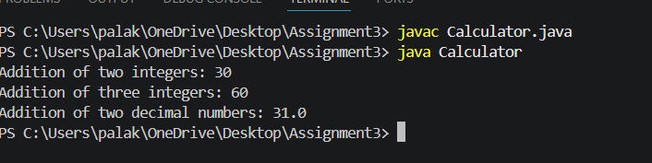

- Display Method
Program:
class Display {

void show(String name) {
System.out.println("Name: " + name);
}

void show(String name, int age) {
System.out.println("Name: " + name);
System.out.println("Age: " + age);
}

void show(String name, int age, double marks) {
System.out.println("Name: " + name);
System.out.println("Age: " + age);
System.out.println("Marks: " + marks);
}

public static void main(String[] args) {

Display obj = new Display();

obj.show("Palak");

obj.show("Palak", 21);

obj.show("Palak", 21, 85.5);
}
}

Output:

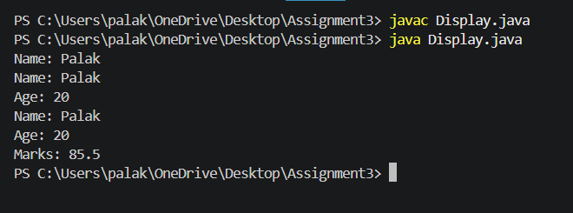

- Find Maximum
Program:
class Maximum {

int max(int a, int b) {
return (a > b) ? a : b;
}

int max(int a, int b, int c) {
return Math.max(a, Math.max(b, c));
}

double max(double a, double b) {
return (a > b) ? a : b;
}

public static void main(String[] args) {

Maximum obj = new Maximum();

System.out.println("Maximum between two integers: " + obj.max(10, 20));

System.out.println("Maximum between three integers: " + obj.max(10, 25, 15));

System.out.println("Maximum between two decimal numbers: " + obj.max(12.5, 15.8));
}
}

Output:

